**COMSATS University Islamabad, Abbottabad Campus**

**Department of Computer Science**

**Project Proposal**

**School Management System**

**CSC392 Object Oriented Software Engineering**

# EHSANULLAH

# REG NO=FA20-BSE-068-4B

# CHAPTER 1 PROJECT PROPOSAL

## Introduction

School Management system, required for effective software development, to manage the overall data of a school

## Vision and Business Case

In the offline system, it is an overhead to keep the records related to faculty, student, parents, and other school staff on the papers. Everything related to their progress in the system is marked manually. For example, A report of a student’s attendance is generated monthly is shown to his/her parents. Now, a regular student, going to school every day, is marked absent for a day by mistake.

It is a burden to take out the register and view the records. As you can see, it is a very time-consuming process and it costs much. So, I thought why I should not help these young guns of the nations to help them to have a bright future and to make an online centralized platform that can be accessed from anywhere in the world.

My other aim is to minimize the paperwork as minimum as I can so that there is no need to cut more and more trees. Indirectly, I will be helping Mother Nature.

## Use-Case Model

The functional requirements of school management system are:

1. Multi-User Account System
2. Student Fee Management
3. Parent Monitoring Feature
4. Homework Document
5. Class Routine Schedule
6. Profile System
7. Exam Marks Management
8. Chart & Graph Analysis of Exams
9. Daily Attendance
10. Internal Messaging

## Supplementary Specification

1. Events management

## Glossary

## Having a dynamic system with a bird view of data and reports can give next level of power and quickness in decision-making for principal or management person. School management System provides extra ordinary Management Dashboard and data reporting functions along with dynamic access rights mechanism which becomes a blessing for management personnel.

## Risk List & Risk Management Plan

***Describes the risks (business, technical, resource, schedule) and ideas for their mitigation or response.***

**1. Malware**

Digital hackers are watching your every move and trick you to download malware and take control of your computer remotely. They use malware to attack computer networks to perpetrate crimes.  Fraudsters use virus, malware, spyware, spams, and phishing to gain access to your sensitive personal information and commit financial crimes. Defend your data against malware through secure servers, whether physical or in cloud, and shield against vulnerabilities.

**2. Theft & Loss**

Unauthorized users without permissions who have access to sensitive data can cause harm to educational institutions as a result of theft. There is a risk of the sensitive academic data will be leaked by staff. It becomes easy to lose your storage media with backup data due to misplacement or theft. When you suffer data loss due to various incidents such as mechanical damage, power failure, software crash, disasters or loss of your laptops and mobile devices, it is another way of inadvertent data exposure. Keep all your data safe and secure using role-based access control to ensure confidentiality and privacy.

**3. Unsafe data**

If adequate safety precautions are not taken when files and documents are shared in website, smartphones and tablets via internet networks, the information contained on them might gain access to the devices and get exposed to risks. We can make use of cloud deployments to manage the education system better and better.

**4. Negligence**

When data is stored in computers or laptops, it has become so natural that people lose the information when files are accidentally deleted or even it could fall into the wrong hands. Ensure a proper backup strategy to keep your data on important devices and run them smoothly without hassles.

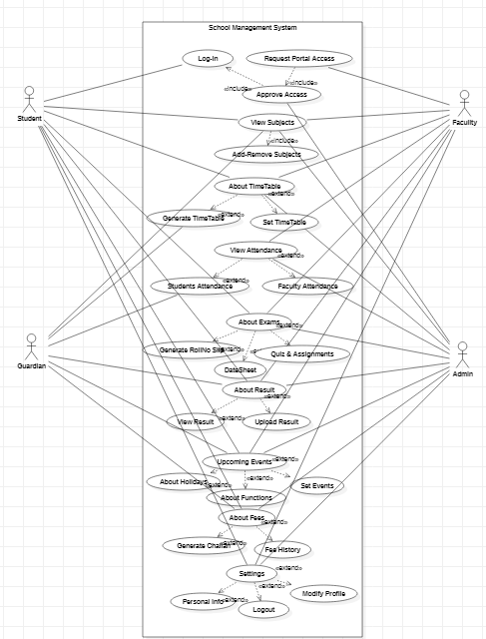

## Brief level use case:

### Ehsanullah (FA20-BSE-068)

#### Use Case: About Result

About Result use case will generate the result for student based on their request for view the result for the subjects. The results of student will be taken by teachers and the record will be submitted on system. The admin and teacher can modify and view the result of student. The guardian and student can only view the result.

### Ehsanullah (FA20-BSE-068-4B)

| Use Case UC1: About Result |
| --- |
| **Scope**: School Management System  **Level**: user goal  **Primary** **Actor**: Student, Guardian, Faculty, Admin.  **Stakeholders and Interests**:  - Faculty: Wants accurate, fast entry, and no text errors.  - Guardian: Wants to view his/her, son/ daughter result.  - Student: Wants easy and fast service with minimal effort. Wants easily visible display of each entered subject result.  - School Management: Wants to accurately view result records and satisfy Student, Faculty, interests.  - Admin: Wants to be able to quickly perform override operations, and easily debug About Result problems.  **Preconditions**: Student is identified and authenticated. |

**Success Guarantee** (or Postconditions): Result is saved. Result is correctly displayed. Result list are updated. Result is generated. Student authorization approvals are recorded.

**Main Success Scenario (or Basic Flow):**

* Faculty marks their result.
* Teacher marks result of students using the system and records is saved in the database.
* The system generates result report for admin.
* System alert guardian if the student is failed.
* Students and guardians can view the real time result.

**Extensions (or Alternative Flows):**

At any time, the internet can be gone:

* During the marking or updating result any time the internet connection may be gone.
* The system will be interrupted, and the teacher will not be able to use the system.
* After the fixing the internet, the user will login and continue back to his work.

At any time, system fails:

* The system can fail any time. The system it will save the work.
* User will restart the system and request for recovery the system will start from the prior state.

If system does not recover:

* The user will suspend the operation and the system will show an error message.
* The user starts a new operation and continue to his work.

**Special requirements:**

* The user should have the computer to use the system.
* The internet must be connected.
* The user should be authorized and authenticated.
* - Touch screen UI on a large flat panel monitor. Text must be visible from 1 meter.
* - Page response within 3 seconds 90% of the time.
* - Language internationalization on the text displayed.

**Technology and Data Variations List**:

The primary actors must have computer connected to internet.